Jamia Islamia Birmingham

CURRICULUM POLICY

Reviewed: September 2023

Reviewed by: Enamul Hoque

Next Review: September 2024

Head teacher: Enamul Hoque

Jamia Islamia Birmingham Curriculum Policy

Our mission is to create a generation of talented, educated scholars, who understand the Islamic way of life from its most authentic sources in accordance with Islam’s own intellectual heritage; whilst reflecting the environment and society they are from with appropriate academic knowledge, so that they may benefit the local community and participate and enrich the wider society. Our alims and hafiz also aspire to become an excellent citizen and have great ambition to become the next batch of doctors, lawyers, engineers, teachers and other professionals at the highest echelons of British society.

Curriculum Overview:

The curriculum policy acts as an overall guide for how teaching and learning practices are implemented in Jamia Islamia Birmingham to ensure that our pupils achieve to the maximum of their potential.

The objectives of this curriculum policy are:

- to ensure pupils achieve to the maximum of their potential
- to provide every pupil access to a broad and balanced curriculum
- to promote collaborative learning
- to ensure necessary planning, assessment, reporting is completed to fulfill every pupil's needs
- to promote cross curricular activities
- to provide an environment which is conducive to teaching and learning and to encourage respect for the school and its surroundings to ensure that both teaching and learning is pleasurable and beneficial to all
- to ensure learning and teaching reflects the schools overarching ethos

Curriculum Aims:

- Learn to be adaptable, how to solve problems in a variety of situations, how to work independently and as members of a team;
- Have high expectations for all but know our students at an individual level.
- Be developing the ability to make reasoned judgement and choices, based on interpretation and evaluation of relevant information from a variety of sources;
- Be happy, cheerful and well balanced;
- Be enthusiastic and eager to put their best into all activities;
- Begin acquiring a set of moral values, e.g. honesty, sincerity, personal responsibility, community participation; on which to base their own behaviour;
- Be expected to behave in a dignified and acceptable way and learn to become responsible for their actions;
- Care for and take pride in their school;
- Be developing tolerance, respect and appreciation of other cultures, religions and beliefs in an unbiased way;

In short, our curriculum covers extensively the following areas:

Linguistic
Mathematical
Scientific
Technological
Human and Social
Physical
Aesthetic, D&T, Creative

Linguistic

Jamia Islamia Birmingham aims to develop pupils’ communicative skills primarily through mandatory KS3 and KS4 English lessons. Pupils are given opportunities to build and develop their listening, speaking, reading and writing skills.

The Modern Foreign Languages (MFL) offered are Urdu and Arabic and it is mandatory for all pupils to follow the course of at least one of these subjects.

Mathematical

Mathematics is a core subject at Jamia Islamia Birmingham and is taught extensively across all Key Stages up to GCSE level. Cross curricular study across other subjects reinforces mathematical approaches and logic for pupils.

Scientific

Jamia Islamia Birmingham provides resources and attention to develop pupils’ scientific and logical skills through its specialised science laboratory. It is compulsory across all key stages. A fully equipped science laboratory provides purpose built facilities for experiments, observations and recordings.

Technological

The purpose built and fully equipped ICT suite provides pupils with an opportunity to enhance their computing skills. ICT is taught as a core subject and is enjoyed across all Key Stages. As part of our new incentive to bring more aspects of technology into the curriculum, we are also teaching Food Technology this year for the first time as part of a carousel scheme incorporating Art and Design.
Human and Social

Assemblies are held weekly and concentrate on PSHE elements across the spectrum. Citizenship lessons for all year groups are mandatory and through these and the assemblies Jamia Islamia Birmingham provides a wealth of human and social skills.
To help students gain a well-rounded understanding and respect of other faiths, their time in school will include visits to religious/cultural institutions such as Churches, Synagogues, Temples, Buddhist MahaVihara, Gurdhwara. These can also be reinforced by speakers coming into school to discuss faith, culture and career opportunities.

History is mandatory for all Key Stage 3 students and this helps to teach many qualities and values to students including: evaluating the past; seeing how best to solve conflicts; learning to live in a sustainable way; the benefits of renewable energy and caring for our planet and environment.

Physical

Jamia Islamia Birmingham aims to develop pupils physical and coordination skills by providing PE lessons weekly. The school is also focused and committed in ensuring additional physiological and tactical awareness skills are implemented.

A range of sports are taught including Football, Badminton, Dodge Ball, Athletics, and Cricket.

Aesthetic - Art

Jamia Islamia Birmingham aims to build on students artistic skills by providing Art and Design as a mandatory subject across all key stages. A particular focus will be given to independent creativity, imaginative processes and composition skills.

Through the school 'Anjuman' programme’ on pupils participate in role play sessions, drama and public speaking.

In Qur’an lessons there is an element of Performing Arts where recitation (Qiraat) is taught. This later allows students to recite and perform in front of public gatherings and be able to become confident, expressive individuals.

Additionally pupils are involved in display work, taking pride in their work and creations. This type of activity is pupil led and offers ample opportunity for students to express their creativity.

Art, Technology and Music are taught in a carousel style for this academic year. The first term will be art based, the second technology based and the third music based. The school is investing in technology equipment for students to use as part of the curriculum.

Personal Development and Career Guidance

Pupils’ personal development skills are promoted heavily during mandatory Citizenship lessons and supplemented by whole school assemblies which have a heavy focus on PSHE issues. Careers guidance is provided during these assemblies where students are given the opportunity to consider a broad spectrum of careers. Preparing students for further education or work is an area that our teachers take pride in delivering. As our teachers hail from many different specialist areas, students are often given insight into the working of many professions. Many students leave Jamia Islamia Birmingham with aspirations to take part in various areas of working life.

Learning structure:

The Jamia Islamia Birmingham is a specialised Islamic School which provides a balance of traditional Islamic education and National Curriculum subjects. Our aim is for students to leave this institution with both a firm understanding of the Islamic sciences as well as a strong academic knowledge of National Curriculum subjects – a combination that will hopefully provide the student with a wide range of possibilities in his/her pursuit of further education. Hence, the school is divided into two sections; the morning is devoted to specialised Islamic sciences whilst the afternoon is devoted to National Curriculum subjects:

The Islamic Section (09:00 – 12:00)

The Islamic Section is further divided into two separate courses:

- Alimi Classes (The Sciences of Islam):
Arabic – Modern Foreign Language
Tajweed – The Science and Art of Recitation
Hadith – Study of Prophetic Traditions
Fiqh – Islamic Jurisprudence
Sarf – Arabic Linguistic Morphology
Nahwa – Grammar and Etymology
Urdu – Modern Foreign Language
Islamic History
Usoolul-Fiqh – Principles of Islamic Law/Jurisprudence
Tafseer - Quran Commentary

Classes are held throughout the week to ensure that fair provision is provided for each for the above mentioned sections of the syllabus. Formative assessments are held twice per year while summative assessments are held once per term.

- Tahfeez al-Quran (The memorisation of the Quran)

The course is split into two sections – Hifz class and Nazirah class. Nazirah class is a pre-cursor to the Hifz Class. The Nazirah course focuses on aspects such as correct pronunciation (Tajweed) and allows one academic year for pupils to recite the Quran to completion. This is also an area where Performing Arts plays a part as students are supported in performing/reciting to a high standard which gives them the confidence to recite in public. The Hifz class builds on aspects of the Nazirah class, where pupils focus on memorisation of the Quran.

Pupils progress is tracked through daily progress, where the three main aspects (revision, sabak, sabakpara) of the course are monitored. Attendance, homework and attainment are all recorded daily. Meetings with each pupil are held to agree target attainments. Feedback in this area is given daily and immediately and students know exactly how to improve themselves at all times. These classes also help students to develop the skill of focus and dedication. The memorisation of the Quran is considered an enormous achievement and it gives students a great deal of self confidence and importance in their communities.

Two formative assessments are carried out through the year while summative assessments occur every month.

Pupils are able to choose only one of the above two courses of study.

National Curriculum Section (Afternoon 12:45 to 16:15)

Every Jamia Islamia Birmingham pupil will study the following core subjects:

- Mathematics
- English
- Science
- Religious Education
- I.C.T.
- Physical Education
- Art & Graphics
- Citizenship Studies
- Modern Foreign Languages (Arabic and Urdu)
- Geography

Mathematics – is taught up to GCSE level and the school follows the Collins textbooks and schemes of work. Additional resources are used from other sources and these are often used for assessments and additional practice for lower achieving students or gifted and talented students according to levels (differentiation). The GCSE is offered by the Edexcel board.

English – is taught upto GCSE level. In Key Stage 3 pupils will follow the scheme of work from Pearson's English Progress books. In Key Stage 4, students prepare to sit GCSEs from the Edexcel board and follow its scheme of work. Teachers use many additional resources to supplement, support and differentiate each pupil according to their level. English Literature has also been introduced this year.

Science- The GCSE is sat through the Edexcel board. Nelson Thorne and Pearson resources are used to help create the schemes of work and additional resource material for the course across all Key Stages. Students will be taking the double science award from this year.

Religious Education – Pupils sit the Edexcel paper at GCSE level and the Edexcel text book and schemes of work are used (published by Pearsons). At Key Stage 3 level, students are taught from a wide range of resources and schemes of work are created by the department.

I.C.T. - Commercial schemes of work are used for this core subject across all key stages. Key Stage 3 focuses on establishing basic ICT principles whilst Key Stage 4 offers pupils an opportunity to advance their skills in desktop publishing software, web development or office suites.

Physical Education – Physical education is offered across all Key Stages. Students are tested regularly with tests such as the Bleep Test and the Illinois Agility Test. When skills are taught in specific sport areas, tests are carried out on the specific skill area and students are given instant feedback on how to improve.

Art – is a subject offered across Key Stage 3. A range of resources are used to create schemes of work and for planning drawing in elements of fine art, composition and food technology. This gives students the ability to express themselves creatively and take part in bigger display projects.

Citizenship Studies/PSHE – Jamia Islamia Birmingham follows the Edexcel curriculum for citizenship. The majority of this subject is discussion and participation based where opinions can be aired and understanding of differences increased. High order citizenship skills include being able to present and debate both sides of an argument and evaluate many contemporary issues. PSHE is integrated in Citizenship lessons in particular but also lessons such as RE and English. Many skills and issues are discussed across many curriculum subjects.

Modern Foreign Languages - The languages each follow the Edexcel board at GCSE level and the departments set schemes of work from a range of resources in accordance with pupil abilities. The languages offered are Arabic and Urdu. Arabic is no longer taught at GCSE level following review of the subject this year.

Humanities – a particular focus is paid on Geography where pupils are able to develop skills. This is now taught to KS3 and KS4.

Performing Arts & Music – pupils are able to practice the arts of recitation (Qiraat), Islamic Song (Nasheeds) and public speaking (Bayan). Vocal melodies, music and rhythms are taught. This is not a subject that is taught directly in the timetable. It takes place in the Quran classes in the morning and also in the preparation for the student presentations that take place regularly.

KS3 and KS4 provisions

 | 7 | 8 | 9 | 10 | 11
English | 4 | 4 | 4 | 4 | 4
Science | 3 | 3 | 3 | 3 | 3
Mathematics | 4 | 3 | 3 | 4 | 4
ICT | 2 | 2 | 2 | 2 | 2
Urdu |  | 1 | 1 | 1 | 1
Arabic | 1 | 1 | 1 | 1
RE | 1 | 1 | 1 | 1 | 2
PE | 1 | 1 | 1 | 1
Geography | 2 | 2 | 2 | 2 | 2
Citizenship/PSHE | 1 | 1 | 1 | 1 | 2
Art | 1 | 1 | 1
TOTAL | 20 | 20 | 20 | 20 | 20

Post 16 provisions:

 | 12 | 13
A level  Business Studies | 4
A level ICT | 4 | 3
A level Mathematics | 3
A level Physics | 3 | 4
A level Biology | 1
A level Chemistry | 1
TOTAL | 16 | 7

Assessments, Reporting and Interventions

Pupils are formally assessed every half term. The assessments are recorded on our School Tracking system and this system is available for all teaching staff to use to further a pupil’s progress. Assessments are compiled to provide a termly report. End of year exams and assessments are compiled and evaluated in the end of year report. Teachers are expected to regularly carry out AfL to ensure that all pupils progress sufficiently. Our assessments take into account the starting points of students. Student Baselines are used from Year 7 to project Target Grades. All teachers and students are made aware of individual baselines and targets in their respective subjects. Students have this data at the front of their books in each subject. Students then take assessments termly and are given Current Grades and projected Forecast Grades. This then helps the school to see if students are performing according to their targets.
At the end of every topic, there is an assessment “end of topic assessment” and this constitutes the end of composite assessment. The marking is done by teacher, data recorded and the assessment is stuck into the books for monitoring progress and for it to act as a revision tool.

At this stage, the heads of the departments are able to identify students that are not making sufficient progress (i.e. 3 levels of progress). Teachers are given Progress Charts to help them map the direction students should be taking and the progress that should be being made. We aim to motivate students to make a minimum of 3 levels of progress and often our students make 4 levels of progress. To get an idea of what 3 levels of progress looks like, the Progress Charts are given to teachers. Teachers also record this information in Seating Plans so as to make sure that they are always aware of students who are underachieving or are gifted and talented.

As an overview of how the system works: a student who enters at level 3 in KS2, after making 3 levels of progress should get a D; 4 levels of progress will be a grade C. A student who enters at level 4 in KS2, after making 3 levels of progress should get a C; 4 levels of progress will be a grade B.

Differentiation

Teachers are expected to plan lessons according to the range of abilities in the class. Jamia Islamia Birmingham has an inclusive policy which ensures that all pupils, low ability to high ability, average learner, gifted and talented, pupils who have English as an additional language, pupils who develop and/or have statements are catered for. Resources are ordered where differentiated work is available. In catering for all abilities, we will identify students who are talented and or gifted and provide appropriate stimulation and challenge to enable further development through the taught curriculum. Jamia Islamia Birmingham feel it is equally as important to identify pupils who have experienced or will experience some degree of learning difficulty and provide appropriate support, through additional teaching if required, and work appropriate to their ability.

Jamia Islamia Birmingham works in close partnership with parents and carers when devising, monitoring and reviewing individual education plans to support the needs of our pupils. The school continually monitors the curriculum, setting targets and evaluating our performance throughout the year and is monitored overall by the Head Teacher and the governing body. Staff are provided with CPD inset training through the year which focus on topics such as differentiation, questioning, using data for assessment and AfL to ensure that teaching is delivered to a high standard and pupils progress. Staff are also given appraisals and targets are set on a termly basis. Learning walks also take place as informal, unannounced visits by members of the Senior Leadership Team. This helps to create an atmosphere of high expectations.

Teachers are given the flexibility to differentiate in their classes in the way they deem most appropriate. Advice, guidance and training are given in different methods of differentiating effectively. Teachers often differentiate by task, providing separate worksheets, or differentiate in an appropriate way for their class. Often teachers will provide a support frame for lower ability students to help them formulate responses and stimulate learning.

The school strategy is to:
- Have differentiation in schemes of work
- Give differentiated homework
- Have seating plans with forecast/target grades visible and lower/higher students highlighted
- Encourage teachers to set clear challenge tasks alongside usual tasks
- Encourage teachers to ask targeted questions and plan questions according to ability
- Monitor differentiation via lesson observations, learning walks and book scrutiny and offer appraisal targets linked to differentiating
- Offer training on differentiation as required

Marking

Jamia Islamia Birmingham recognises that marking is the key to assessing pupil progress. Marking is used to provide feedback, offer strategies for improvement, consolidate and extend learning. It ensures that students are aware not only of their current achievements, but are also aware of their expected target. Feedback helps pupils to gain a clear understanding of how well they have gained knowledge, concepts and skills and what needs to be done to meet the learning objectives.

Teachers are expected to fully implement this through regular marking of end of topic assessments. Marking should consist of teacher written feedback, peer assessment and self-evaluation. If written, teacher feedback should be in green ink and if typed, it should clearly be visible as “Teacher Feedback”. Verbal Feedback marks/stamps can be used as well. Student responses, self-assessments and peer assessments should all be in red ink. This can then be used to show students responding to teacher feedback and therefore making progress.

The marking policy is as follows. Teachers are expected to check books and give verbal feedback on a regular basis. Formal written feedback is to be given considering the benefit of the students. Formal feedback is to be prescriptive and some subjects will find themselves being given more formal feedback (e.g. mathematics) and others (such as Art) may find written feedback to be less frequent. In the past, we have given fixed amounts of feedback but have found that these can be inaccurate and not very beneficial to the students. Having taken advice from consultants and inspectors, we have thought it better to give teachers flexibility in their marking, as long as student benefit is the main goal.

Teachers are expected to circulate and give verbal feedback in most lessons. Students should be shown “what a good one looks like” and common faults and errors should be highlighted on the board during the lesson. If the teacher spots the common mistakes that students are making and this is addressed on the board with examples and then a chance for students to try again is given; this entire process can take place within a lesson. The feedback is immediate, diagnostic and prescriptive. We are encouraging teachers to use this type of feedback more regularly.

At Jamia, we have found that students benefit most from immediate feedback from circulating and correcting misconceptions in the lesson rather than afterwards.

Literacy

As part of our target to improve literacy in the school, we incorporate a marking code to highlight literacy errors in student work. This marking code is used across all subjects and it is expected that at least one written piece of work per marking cycle is marked thoroughly with literacy in mind.
This marking sheet was given to students for them to be familiar with marking for literacy. Alongside marking for literacy, the English department also monitors students’ reading by a regular reading journal which is checked and signed. Students are also given regular access to the school library and they have reading corners in their classrooms also where a selection of books are made available for them to read.
At KS3, every Friday at 2pm to 2.20pm Jamia Islamia implements a drop everything and read (DEAR) strategy to support literacy. During this time, students are encouraged to read to their teacher, their peers or a loud to the classroom if they are confident enough to do so.
Students at KS3 are also expected to have spelling books out in every lesson and to make a note of new vocabulary that they come across. These spelling books are also to be used as practice for words that they spelt wrong and were highlighted during marking.

Extra-Curricular

As part of Citizenship lessons, and PHSE / PD lessons, all pupils across all key stages will have the opportunity to make visits to religious/cultural institutions. This is to enable students to be exposed to positive role models across all cultures and faiths as well as to increase understanding, tolerance and harmony with the community at large.
Additionally, pupils will be engaged in activity based field trips to ensure that they are exposed to and able to experience a range of activities. Trips often include places of learning, museums, art galleries, science exhibits and theme parks.

The school council will continue to run and will be given particular focus by the head teacher to ensure that this becomes a thriving and productive extracurricular activity.

Key stage 3 and 4 students also have the opportunity to raise money for charities and take part in other community activities.

We also encourage students to participate in extra-curricular clubs at the school. Below is the list of after school and lunchtime clubs available for students to participate in:

Tuesday: Debating society – current affairs
After school
Run by Dr Siraj Shaikh 4.15pm to 5pm

Wednesday: Badminton club
After school
Run by Enam Hoque 4.15pm to 5.15pm

Thursday: Naat and poetry competition
Lunchtime
Run by Sadiq Ahmed

Curriculum intent
The KS3 and KS4 curriculum at Jamia Islamia has been developed to teach students the most powerful knowledge in each subject area. Alongside teaching of the academic curriculum we support the inculcation of equality, inclusion and interaction through a carefully crafted SME programme. The skills and knowledge gained through the academic curriculum which also encourages students to explore community and enterprise is essential to enable our students to be empowered and contribute to society.
Recent times have shown the need for everyone to build a sense of resilience in dealing with a global pandemic. Resilience is a core value for us and is developed further in our curriculum as change and continuity, where lessons are sequenced in a structured manor enabling students to build on prior knowledge, as well as synthesise across topics and subjects. Although a linear approach is present in the curriculum, a network of links can be drawn between themes, topics and subject to show why certain topics are covered at particular times in the academic calendar. This is carefully constructed to fully support our student’s ability to internalise the knowledge gained across all subjects.
We believe that the choices we make about the content we provide and the order we present it are crucially important. They make a big difference to how students are able to develop effective schema, retain and recall knowledge and skills in long-term memory. We actively promote knowledge transference from short term to long-term memory through the use of regular retrieval practice.
We have high expectations of what the students at Jamia Islamia can achieve. To help our students to have successful outcomes, the most powerful substantive and procedural knowledge is carefully selected to ensure that the curriculum is knowledge rich and ambitious. We want to promote life-long learning and provide our students with the cultural capital needed to become excellent global citizens.
In keeping with our inclusion pillar, we believe every student should have access to the same breadth of curriculum. Carefully selected scaffolding is used for all students to reach equally challenging learning goals and have secure skills and knowledge in each subject.
As part of building resilience, we believe all students should be challenged and seek deeper knowledge and understanding. Embedded within the curriculum are opportunities for students to deepen their understanding through the use of the blue box challenge. These activities provide the opportunity for the students to think more extensively or consider different applications of the substantive and disciplinary knowledge they have been introduced to.
Assessment opportunities are carefully planned so that they are purposeful and support learning. Information from assessment supports our evaluation of the effectiveness of our curriculum content and implementation. Assessments include low stake knowledge retrieval quizzes, end of composite assessment and GL assessments.
Our curriculum pillars in the classroom:
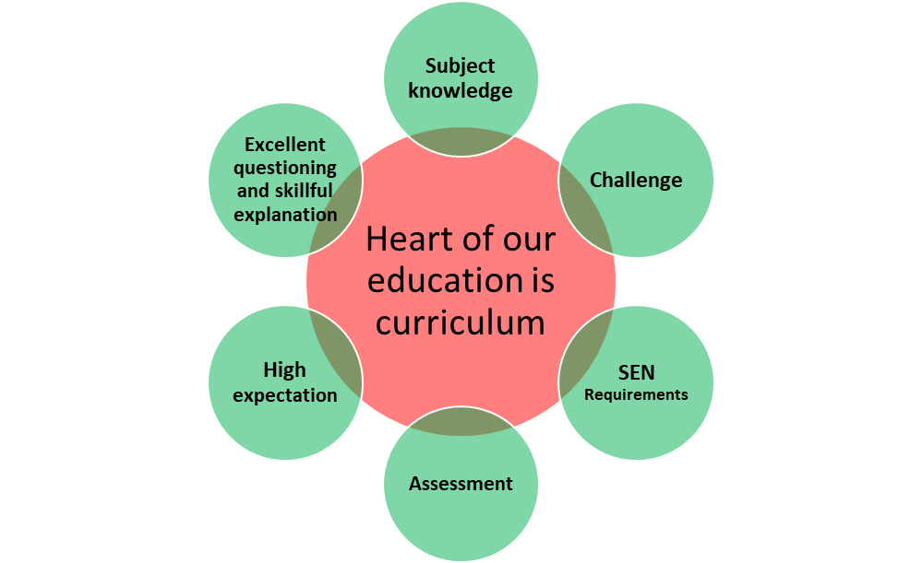
The Jamia Islamia Lesson
1. Knowledge retrieval starter
· The starter activity is usually a low stakes knowledge retrieval quiz based on previous lesson.
· The task should take no more than 5 minutes including review and should be done in silence.
· Answers to each question must be reviewed using targeted questioning.
2. The cycle: The lesson should be ‘chunked’ into cycles.
· Teach/model – A process or concept is modeled focusing on knowledge – ‘I do’
· Application – An opportunity for students to apply their knowledge and draw links to community & enterprise and change & continuity. – ‘We do’ and ‘You do’. The teacher needs to complete a collective demonstration of the topic, substantive or disciplinary knowledge with the students during the ‘we do’ phase. The ‘You do’ phase needs to be the phase where the students are independently applying what they have learnt. Appropriate scaffolding is required to support students and SEN requirements need to be taken into account. The task should be differentiated by outcome not by objective.
· Assessment for Learning – Learning is assessed through targeted questioning, learning checks, and test questions. Misconceptions are addressed and future lesson planning is informed.
· The learning cycle may be repeated throughout the lesson to ensure effective ‘chunking’
3. Blue Box Challenge
· Each learning cycle will feature a blue box challenge.
· This is not a ‘do more’ task but an opportunity for students to extend thinking, deepen knowledge and build resilience.
4. Plenary
· The plenary is an opportunity to assess key substantive knowledge and procedural knowledge and student outcomes.
· A plenary task may be early exposure to past exam paper questions, an inverse thinking task or a debate style discussion, which links the topic to community and enterprise.
· Every lesson needs to finish with an ‘Exit Ticket’ for students to demonstrate learning.

Implementation of the curriculum
Curriculum planning documents
Long term plan: Each department details their high level plan and overarching subject curriculum intent in the long term plan.
Intent Statement - The intent statement explains the ‘big ideas’ that each subject will consider and is the basis for all subsequent curriculum choices. It considers the disciplinary and substantive knowledge that will be developed, and the cohering strands that will thread the curriculum. Each subsequent curriculum choice promotes learning over time and the development of the students’ long-term schema.
Medium Term Plan: The medium term plan details how blocks of the content are broken down into sequences of learning, using the composite and component structure. The diagram below shows a typical composite and component structure:
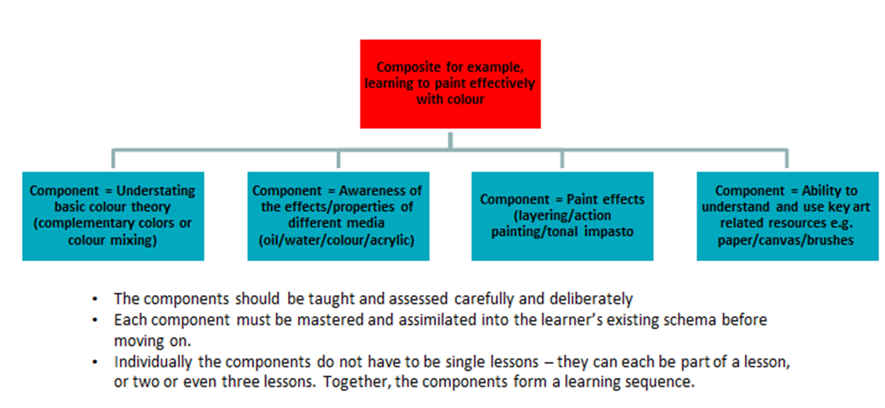
Example - 2023
The medium term plan outlines precisely and in meticulous detail what the pupils will be learning. It will detail declarative (‘Students will know that….’) and procedural (‘Students will know how to…’) knowledge.
How will we assess the impact of the curriculum?
Work Scrutiny: To assess
· The progress of learning over time
· The progress of the curriculum priorities
· The quality of students’ work
· The impact of student intervention and SEN requirements of students
Learning Walks: To support
· The quality of teaching and learning identifying strengths and development opportunities
· The impact of whole school CPD / Coaching
· The effectiveness of student interventions
· Opportunities for development
Stakeholder’s voice: To listen
· To the opinions of all stakeholders
· To any new ideas or any concerns or barriers to learning and teaching
Assessment Data: To identify
· Gaps in students’ knowledge through use of QLA data
· Opportunities to address and develop the curriculum further
· Any learning gaps and student’s knowledge retention skills
Lind Management: To consistently
· Approach whole school priorities
· Determine the effectiveness of faculty systems
· Identify any support that is needed to develop people and teams

